
“Closer and Closer”
A Watercolor Journal Entry, by Laurie Price
based on “The Secret Garden,” by F. H. Burnett
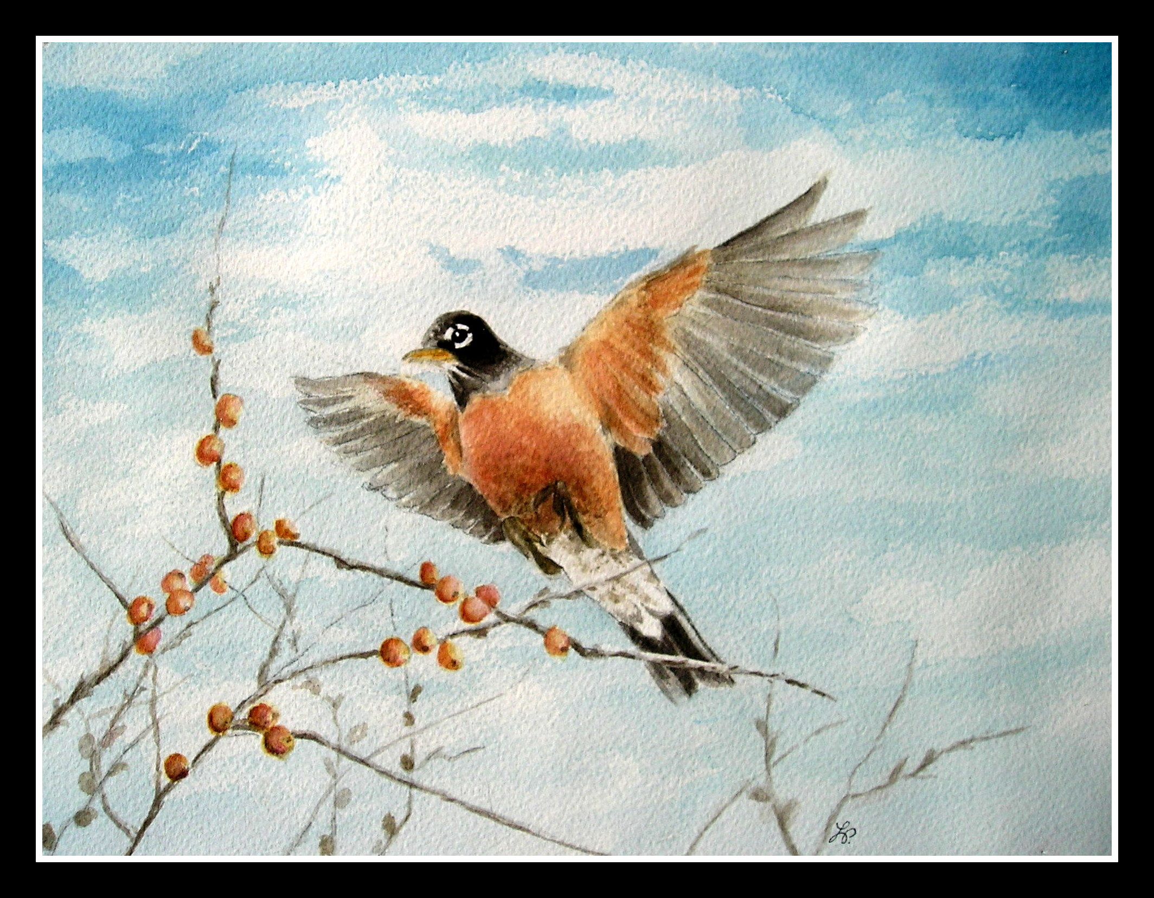
"Oh! look at him!" exclaimed Mary.
The robin was evidently in a fascinating, bold mood. He hopped closer and closer and looked at Ben Weatherstaff more and more engagingly. He flew on to the nearest currant bush and tilted his head and sang a little song right at him.
"Tha' thinks tha'll get over me by doin' that," said Ben, wrinkling his face up in such a way that Mary felt sure he was trying not to look pleased. "Tha' thinks no one can stand out against thee-that's what tha' thinks."
The robin spread his wings-Mary could scarcely believe her eyes. He flew right up to the handle of Ben Weatherstaff's spade and alighted on the top of it. Then the old man's face wrinkled itself slowly into a new expression. He stood still as if he were afraid to breathe-as if he would not have stirred for the world, lest his robin should start away. He spoke quite in a whisper.
From Chapter 10, The Secret Garden
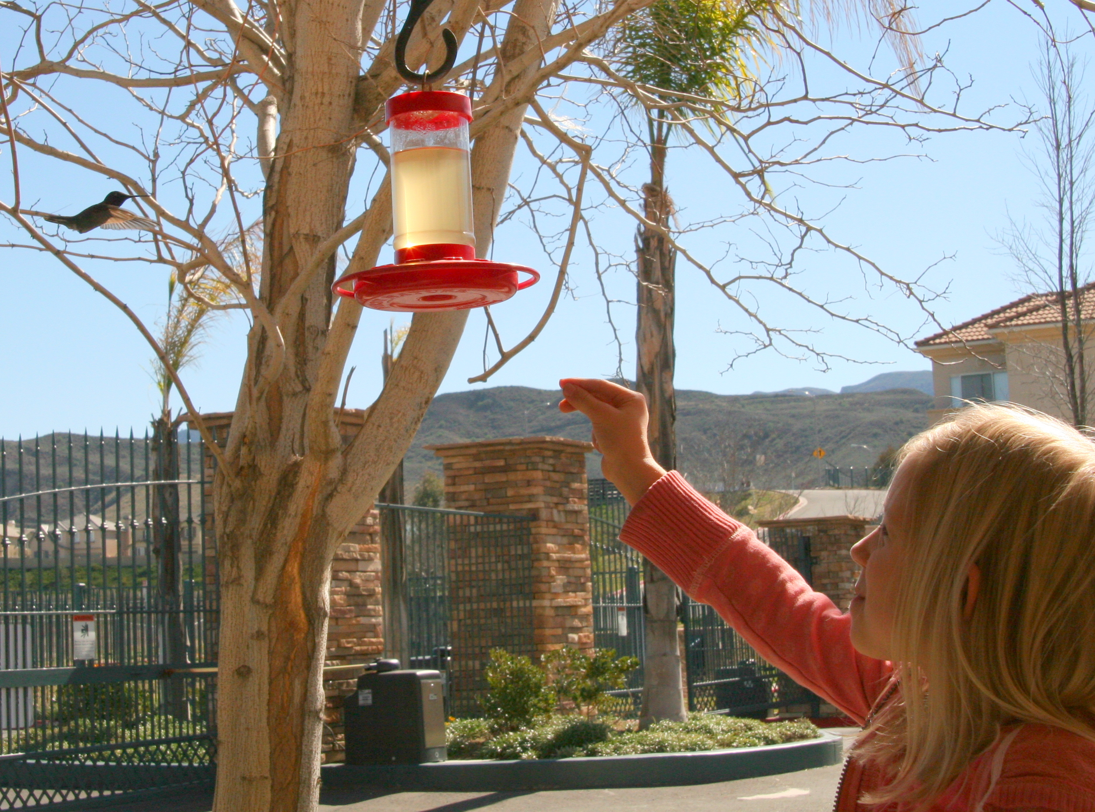
A few weeks ago, my little granddaughter was excited to show me her friendly hummingbird. She learned that if she sat very still, near the feeder, the hungry bird would come quite close. It’s hard to be patient, but she lifted her hand and “froze” whenever he was near, and he hovered right there. The little birds are a wonderful brush with wild things, the “magic” of our own secret gardens, and so we love them.

