“ Lil’ Bandit”
A Watercolor Journal Entry, by Laurie Price

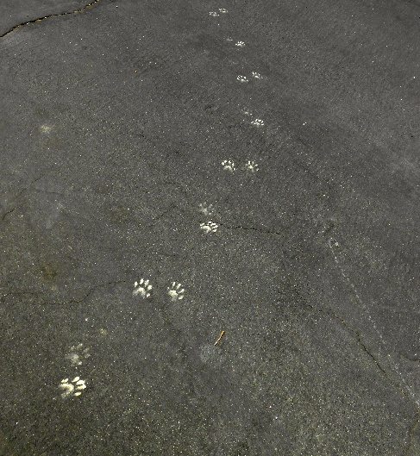
Furry, cute, and oh so sneaky! Everyone has a good raccoon story. My favorite took place at our old house. With the Koi pond, and it's shallow rock waterfall, raccoons and possums were around from time to time.. A place to wash food, an occasional fish food pellet, ornamental grass which hosted grubs, and worms, to say nothing of the tempting fish. Gary had built the patio over hanging the pond a little, so that the fish could hide from predators and most of the fish were too big for a raccoon to pull out, but all the other goodies in our garden were in abundant supply. Anyway, we knew they were there, our dogs kept us informed of that in the night. Being nocturnal, I always wondered where they went in the daytime. Our tree trimmer found out one day, when pruning a palm tree. Up on a very tall ladder, and deep into the thickest part of the palm fronds, he came face to face with a big raccoon. It was right next to our pond, and had made a nest there. Both of them were surprised, and Mike took a quick exit. When he went back up, Mr. Raccoon was gone.

When we take Gary for a walk every morning, guess what we see? Evidence! We've got raccoons here too, and I love knowing that. I saw muddy prints in our little garden right outside our living room window, so I know they are close by. We criss-cross their paths as we walk through our little neighborhood. I wonder where they go in the daytime? What tree, or bush do they live in? Are they curious about us too? Seeing these little prints day after day, reminded me of our little ecosystem by the pond, and inspired me to paint Lil' Bandit. Love the daily "brush" with critters, and capturing them with MY brush!

